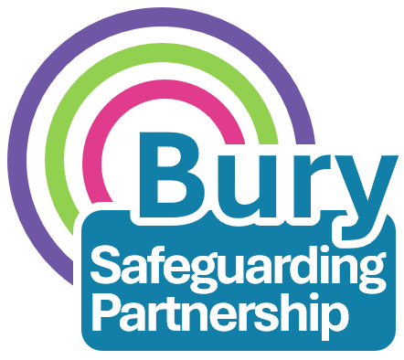

Bury Safeguarding Children Partnership
Resolving professional differences / escalation procedure

This document must be read alongside the Greater Manchester Safeguarding Children Procedures Manual on resolving professional differences / escalation policy. There is further guidance around specific situations on this.

When professionals are working together in the complex business of safeguarding children there will inevitably be occasions when there are professional differences of opinion. Constructive challenge is an important component in positive partnership working, but where differences of opinion cannot be resolved quickly and easily, practitioners have a duty to take action to address professional disagreements in a way that is appropriate, timely and proportionate. Bury Safeguarding Partnership wish to empower professionals from all agencies and ensure that their expertise and instinct is considered when making decisions around the welfare and wellbeing of children and young people.

What is this process?

This process outlines the steps to be taken when there are concerns raised by practitioners from agencies in relation the safety and welfare of a child or young person, and / or action being taken to safeguard a child or young person. Concerns raised may be due to a disagreement between agencies or a shared concern. Challenge must be evidenced based and recorded on the child’s file, including details or how the resolution improved outcomes for the child and/or family. Disagreements should be raised verbally wherever possible, for example, in the meeting it should be made clear that there is a difference of opinion, so that all viewpoints can be understood. This can then be followed up in writing.
It should not be confused with the process to be followed for making a referral to the Multi Agency Safeguarding Hub (MASH) when there is a child protection concern. A single agency may choose to escalate a professional disagreement with another agency or, if appropriate, more than one agency may choose to jointly escalate an issue.

Why do we need this process?
Learning from rapid reviews and local child safeguarding practice reviews highlights the importance of resolving professional differences of opinion to ensure that children and young people are not left at risk of harm. If sufficiently serious, and when disagreements are not able to be resolved, it is important that they are escalated formally and recorded.
Who is this aimed at?
This process is aimed at all levels of agencies, from practitioners to strategic leaders, across statutory and non-statutory agencies. The levels within this protocol should be interpreted by all agencies, in a way which allows the application of relevant roles and job titles in individual agencies within the operational structure of this protocol. Ensure your safeguarding lead is consulted with throughout the escalation process. Please attempt to resolve any disagreements informally, before initiating the formal process.

If the manager / named safeguarding lead are unable to achieve a resolution, they should refer it to BSCP Business Manager. The template regarding this can be seen in Appendix 1. This may take the form of a meeting, or phone conversations.
A further meeting will be facilitated between the BSCP and the referrer and agencies involved with the purpose of achieving a resolution.
Where matters remain without resolution at this level further oversight will be sought from the Executive of the Partnership or the Independent Scrutineer.
Level 4: Exceptional Circumstances - BSCP
Within one week
To note:

Timescales should be agreed at each stage, ensuring the outcome for the child is dictating the agreed timescales. Each stage should not exceed 10 working days.

A clear record should be kept by everyone at all stages
Where resolution cannot be achieved through line management this should be referred to equivalent heads of service. If the matter remains unresolved, then the matter must be referred to equivalent directors/assistant directors within 2 working days.
Meetings should be arranged to discuss a final resolution. Key points should be confirmed in writing after any discussion.
Documentation relating to escalations resolved at this stage should be provided to the BSCP Business Manager for tracking of thematics.

Level 3: Head of Service to Head of Service
Within one week
Escalate to your line manager or lead for safeguarding. Your manager should discuss the concerns / response with their opposite manager in the other agency. Key points should be confirmed in writing after any discussion. Professionals are responsible for finding out the key contacts in the relevant agency should they wish to escalate a matter under this procedure. If there is difficulty in this, the BSP can be contacted for assistance (bsp@bury.gov.uk).

Level 2: Line Manager to Line Manager
Within one week
If resolution not achieved, progress to Level 2
Level 1: Practitioner to Practitioner
When professionals cannot agree with a decision or response from any agency in relation to:
• determining the levels of need for a child or adult at risk
• roles and responsibilities, and
• the need for action and communication re: a safeguarding issue, initial attempts should be made between the workers to resolve the issues informally
Disagreement can be raised either in writing or verbally (it is the preference to raise disagreements verbally so all viewpoints can be understood, and we would encourage professionals to raise any differences of opinion directly in the meeting.
Key points should be confirmed in writing after any discussion. Attempt to resolve as soon as possible. Inform the lead professional/chair at this stage. The expectation should be to resolve difficulties at practitioner/case worker level between agencies.
APPENDIX 1

Request for Resolution Document

THIS DOCUMENT MUST BE SENT/STORED SECURELY TO bsp@bury.gov.uk

Date of Notification
Name of Child/Young Person
D.O.B
Outcome Resolution Notice Referrer details:
Name
Role
Agency/Team
Contact Details
Designated safeguarding lead aware of this notice? | Yes / No  Name of safeguarding lead:
Summary of disagreement
Evidence of the challenge that has taken place at stages 1, 2 & 3 and the outcome at each stage
Desired outcome for the child and / or family. Please include details of what it is you are requesting happens as a result of this challenge

Stage | Date Outcome Resolved | Supporting Evidence  Embed written confirmation between parties about the agreed outcome
Stage 3
Stage 4 (to be completed by Safeguarding Partnership Business Unit) |  | Final decision of:

Once stage 4 has concluded, the escalation notice will be completed, and a copy of the notice will be sent to the referrer informing them of the decision in writing.

